# Linux Commands

* **mkdir**: -

We use this command to create a new directory.

$ mkdir Directory_name

**Screenshot: -**

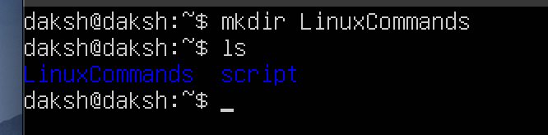

* **ls**: -

We use this command to list all the files and the folder which are there in your current directory.

$ ls

**Screenshot: -**

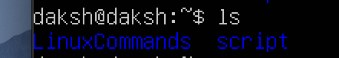

* **pwd**: -

This command shows your current directory in you are present in. $ pwd

**Screenshot: -**



* **cd**: -

We use this command to move through different directory.

$ cd directory_name

**Screenshot: -**

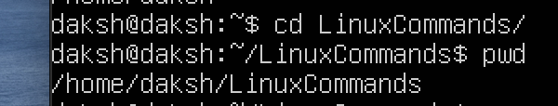

* **clear**: -

We use this command to clear the whole terminal. If it is filled with commands, then if you use `clear` command then your terminal will be cleaned.

$ clear

**Screenshot: -**

Before

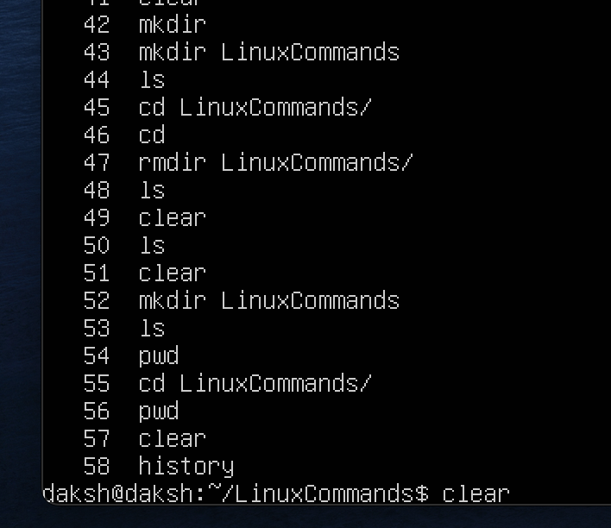

After

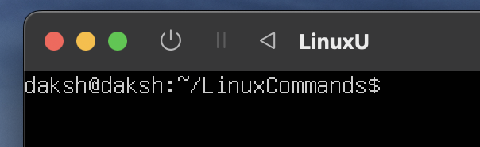

* **touch**: -

We use this command to create files and we can add specific extension on that file in the end.

$ touch File_name.extension

**Screenshot: -**



* **cat**: -

We can use this command for multiple purposes which I will try to list down below: -

1 Viewing the file ($ cat File_name)

2 Viewing and editing the file ($ cat > File_name.extension)

3 Merging the files ($ cat File1 File2 > MergedFile)

**Viewing the file: -**

We use the cat command here to just view the file and we cannot edit it further if we want to.

$ cat File_name.extension

**Screenshot: -**

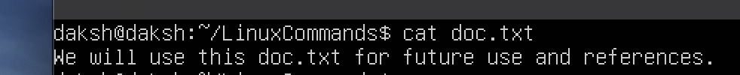

**Viewing and editing the file**: -

We will use the cat command to view and edit the file if we want to.

$ cat > File_name.extension

**Screenshot: -**

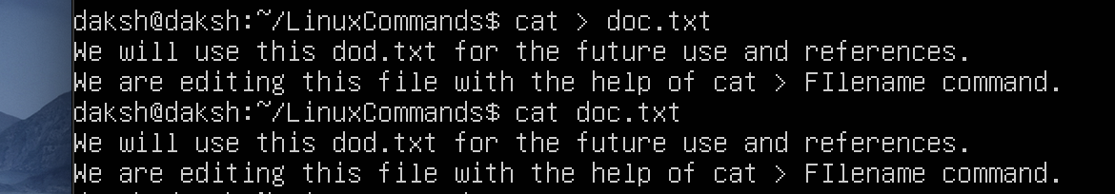

We can see here that the file was edited.

**Merging the files: -**

We will use the cat command here to merge two files into a one new file.

$ cat File1 File2 > MergedFile

**Screenshot: -**

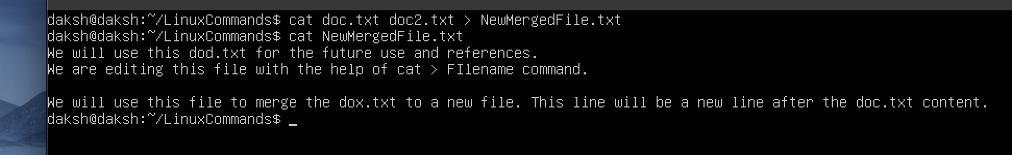

* **vi: -**

Creates a new file if it already does not exist, otherwise opens an existing file and you can edit it. Once you open the vi editor you must press `i` to edit the file. Once you are done with the edit you can press `:wq` to exit and save the file or only `:q` to exit without saving the file.

$ vi File_name.extension

**Screenshot: -**

Command



Result

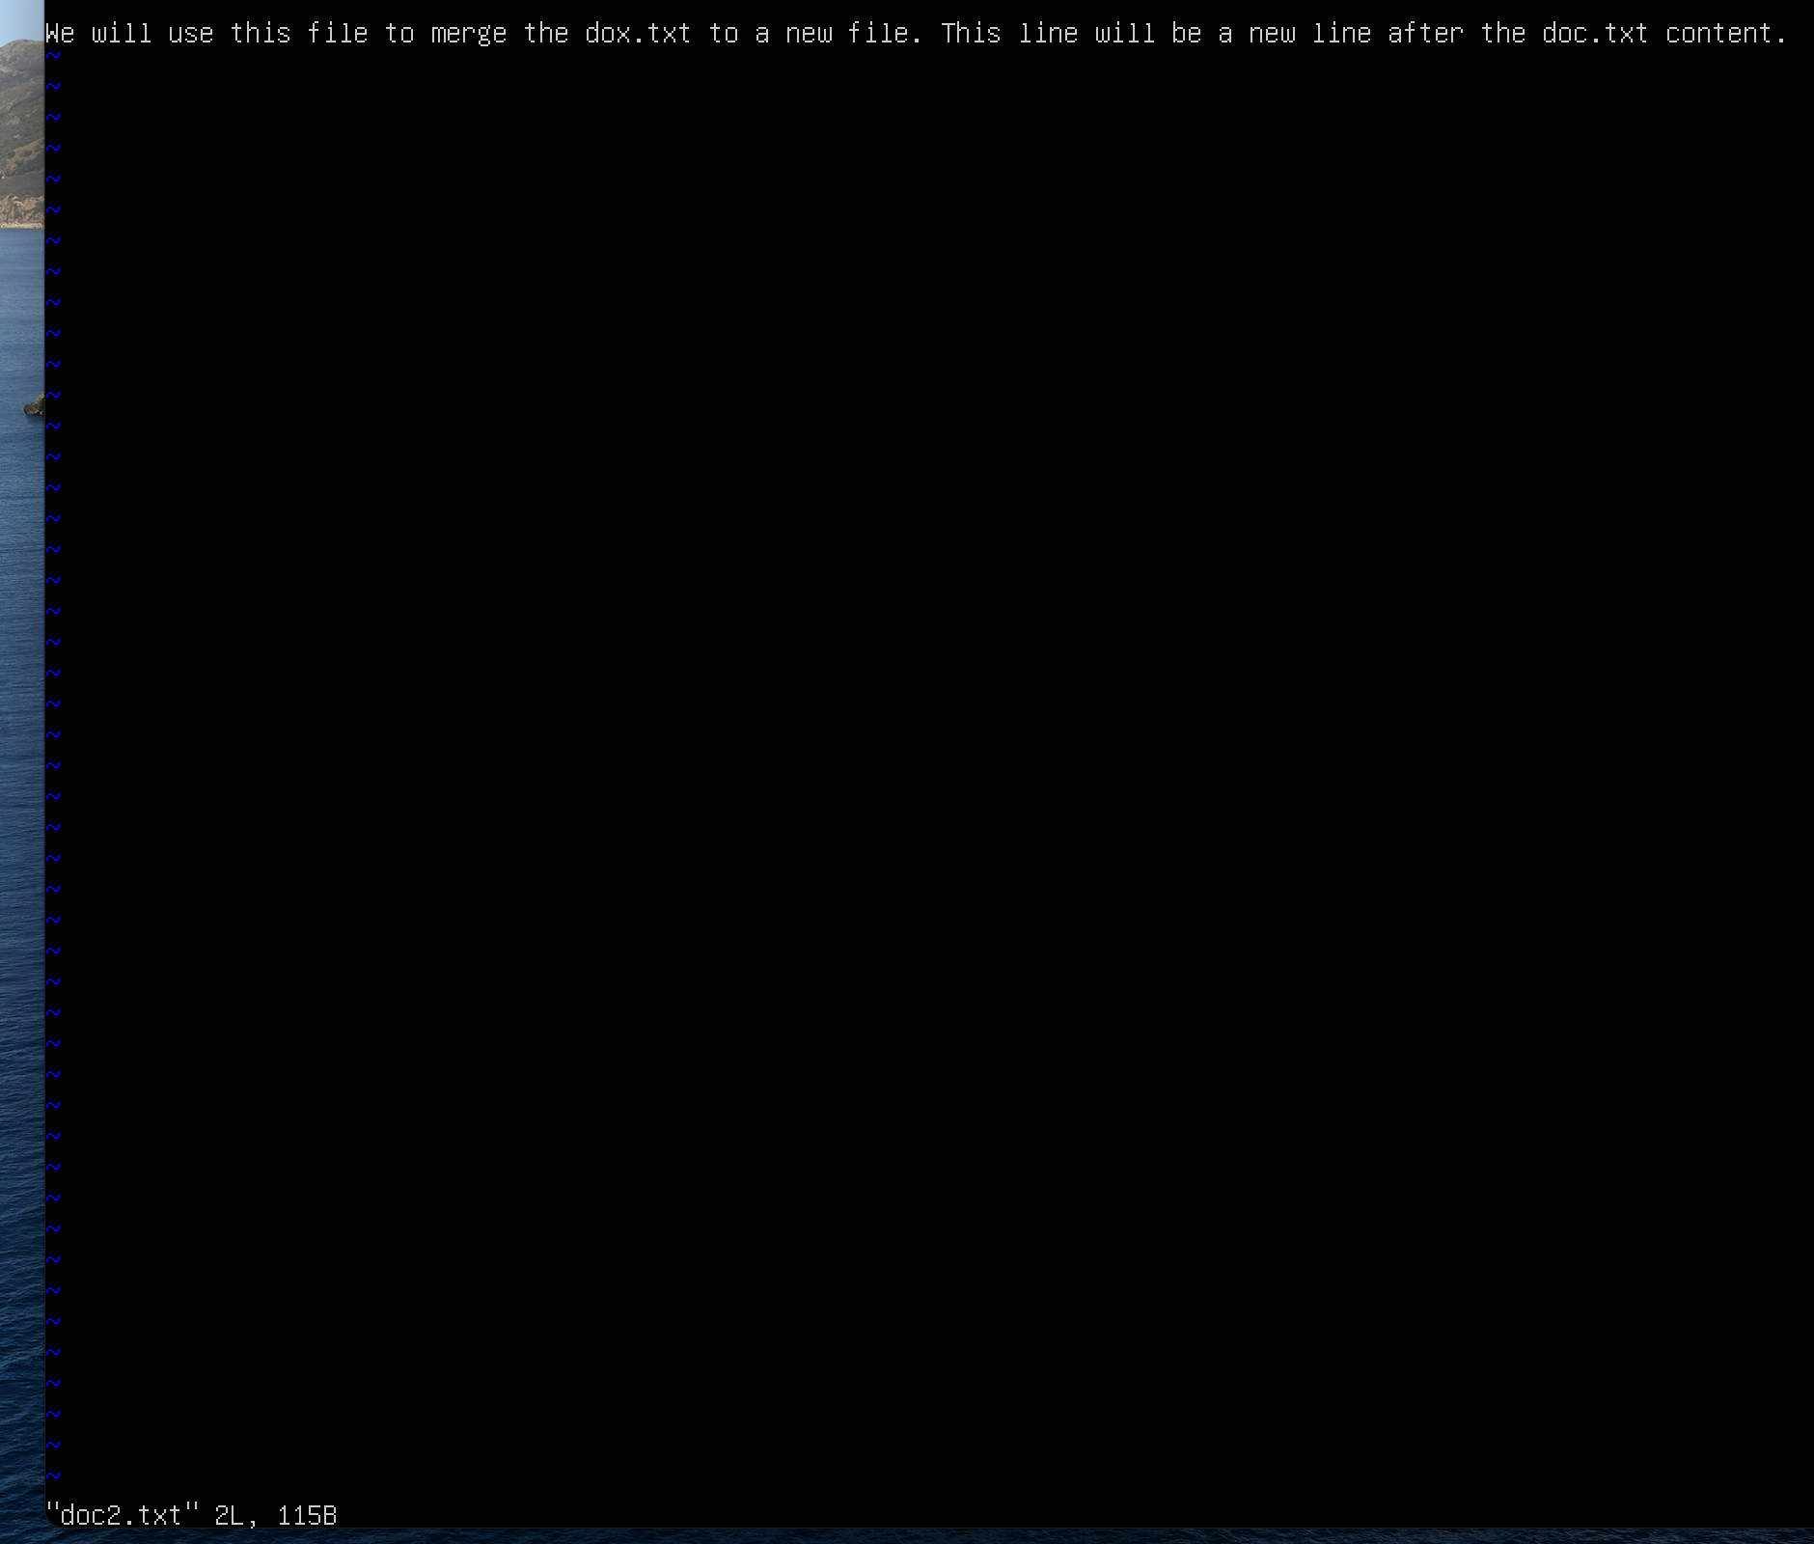

* **more**: -

We can use this command to view the file. It is similar to the only `cat` command. In more command you can press enter which will help you to move forward in the file and you can view the coming lines easily.

$ move File_name.extension

**Screenshot:-**

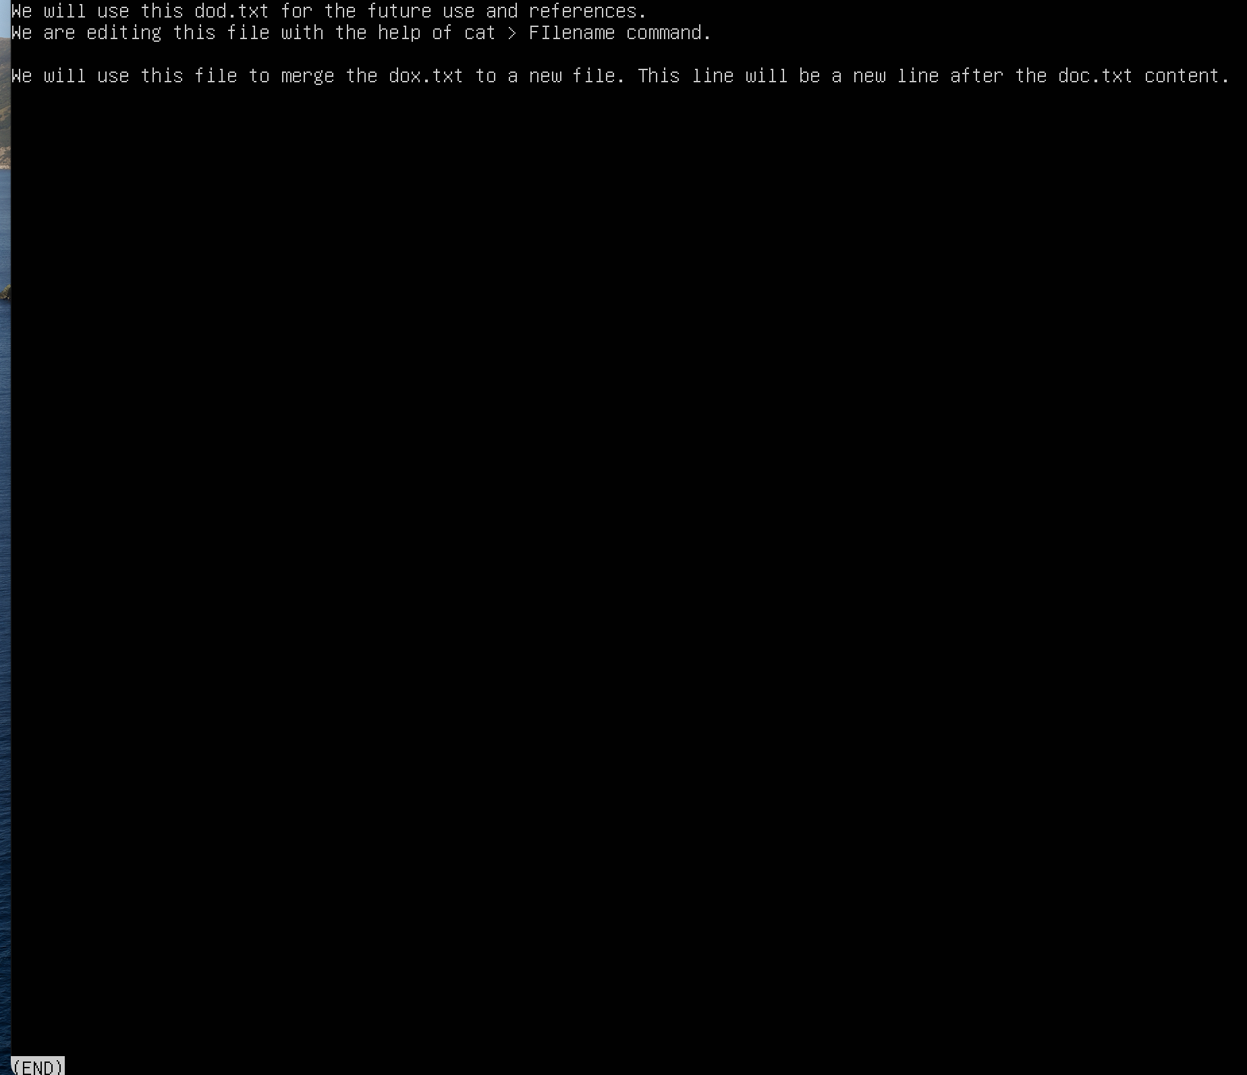

* **ls *.extension**: -

This command will only list then file that have the extension which is mentioned after `.`.

$ ls *.extension

**Screenshot: -**

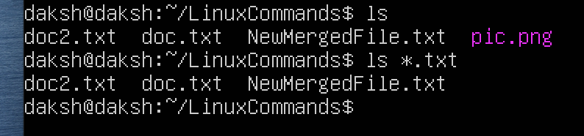

* **cp**: -

We use this command to copy the content from one file to other file.

$ cp File1.txt File2.txt

Here the content from File1 will be copied inside the File2. Also if this File2.txt doesn’t exist then it will create a new file called `File2.txt` and copy the content from `File1.txt` to this new file.

**Screenshot: -**



* **tac**: -

This command will just reverse the line and give it as output.

$ tac File_name.extension

**Screenshot: -**

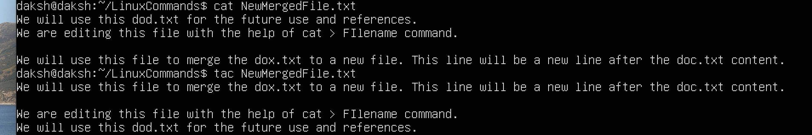

* **head and tail**: -

Head command will print the first 10 lines of the file and the tail command will print the last 10 lines of the file.

$ head File_name.extension

$ tail File_name.extension

**Screenshot: -**

Tail

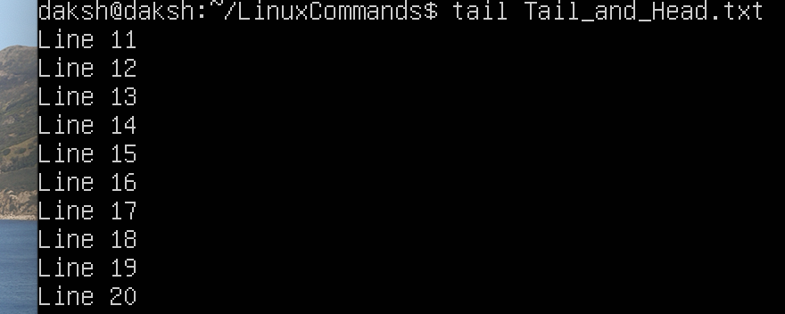

Head

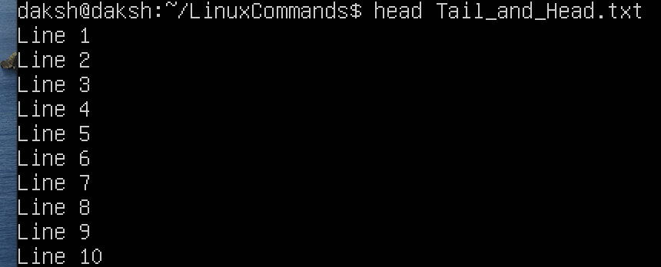

* **id**: -

Displays id of the user group.

$ id

**Screenshot: -**



* **grep**: -

This command help us to filter out the word that we want to see in the specific file.

$ grep File_name.extension

**Screenshot: -**

Here we can see the word Line been highlighted that we searched for.

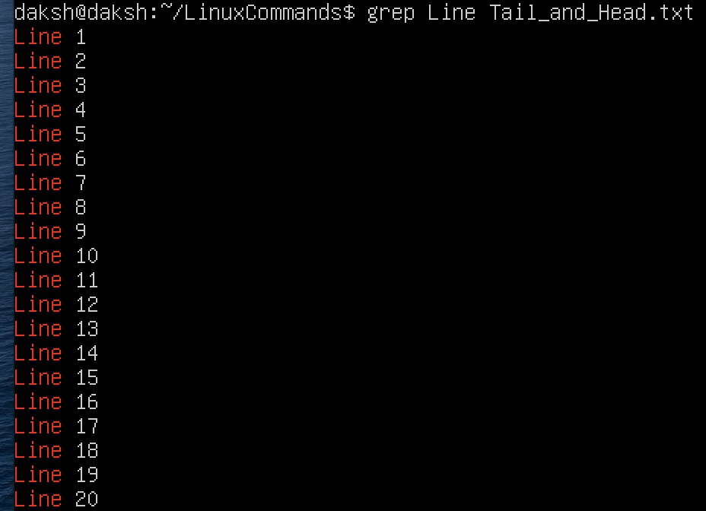

* **diff**:-

This command compares the differences in the 2 files.

$ diff File1_name.extension File2_name.extension

**Screenshot: -**

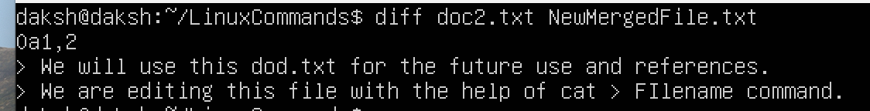

* **rmdir**: -

We use this command to delete a directory.

$rmdir Directory_Name

**Screenshot: -**

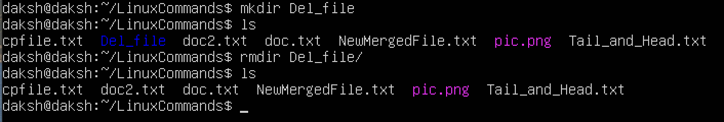

* **ping**: -

We use this command to ping a specific ip or a hostname. We have to press ctrl + Z to stop the ping.

$ ping IP/hostname

**Screenshot: -**

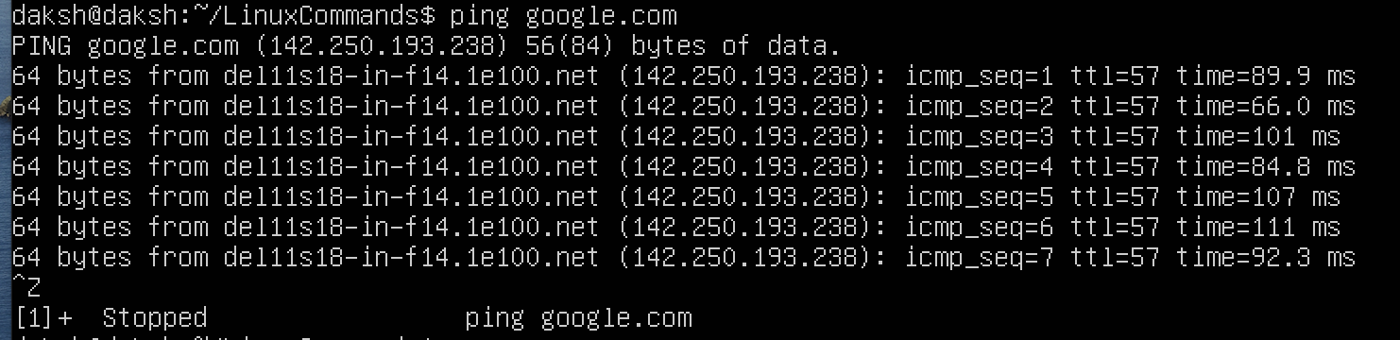

* **nl**: -

We use this command to print a file but the difference between this command and the normal cat command this that when you use `nl` it will print all the lines in the file starting with the number.

$ nl File_name.extension

**Screenshot: -**



* **wc**:-

We use this command to print out the info of a specific file. The output will be in the format [Line Word Character]

$ wc File_name.extension

**Screenshot: -**



* **hostname**: -

Prints the host name where you are present.

$ hostname

**Screenshot**: -

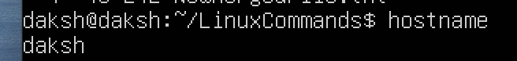

* **hostname -i**: -

Displays the ip of the host.

$ hostname i-

**Screenshot**: -

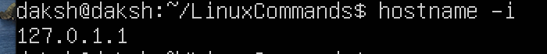

* **uniq**: -

We use this command to remove the duplicate words from the specific file.

$ uniq File_name.extension

**Screenshot**: -

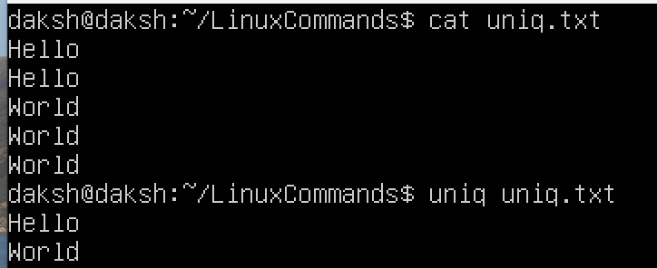

* **chmod**: -

We can use this command to change the permission on the files. You can add and remove the permissions on the file that you want.

$ chmod permission File_name.txt

**Screenshot**: -

